Data Model Architecture (Star Schema)

The data model for the Greenlight Risk Engine has been architected using a high-performance Star Schema. This design decouples descriptive dimensional attributes from core transactional metrics, ensuring highly optimized query performance and clean DAX calculation paths.

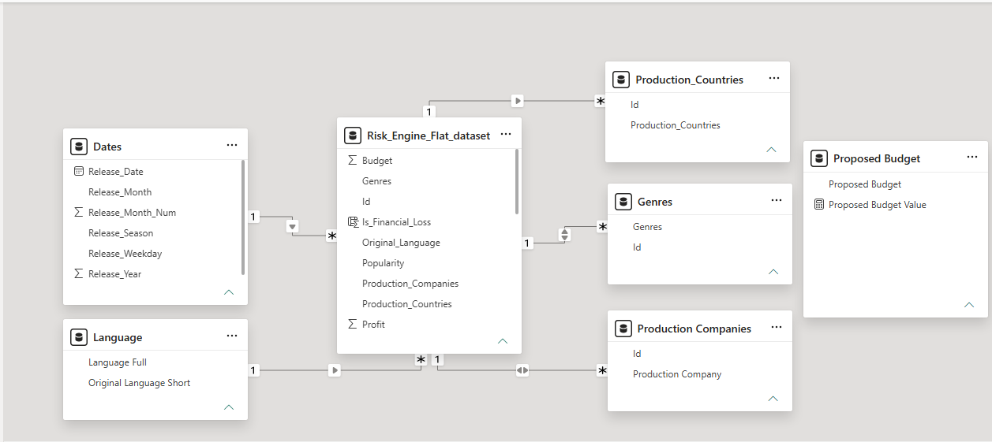

Central Fact Table
`Risk Engine Flat Dataset`: Serves as the central data core containing primary numeric metrics (Budget, Revenue, Profit, Popularity, and custom risk calculations).
Dimension Tables (1 \rightarrow * Relationships)

Dates` to Fact Table: Established as a One-to-Many (1 \rightarrow ) relationship. The cross-filter direction is strictly set to Single-direction to ensure optimal engine performance and avoid circular evaluation paths during time-intelligence calculations.
‘Language` to Fact Table: Mapped as a One-to-Many (1 \rightarrow ) relationship, grouping historical movie records by their structural language metadata.
‘Genres` to Fact Table: Configured with a One-to-Many (1 \rightarrow ) relationship. Because individual movies frequently carry multiple genre tags, the text strings were normalized and unpivoted into individual structural rows
during the ETL process. A Bi-directional filter was chosen here to yield precise cross-filtering aggregations across specific genre selections.
‘Production Companies` to Fact Table: Formatted as a One-to-Many (1 \rightarrow ) relationship. Similar to the genre dimension, movies containing multiple production studio arrays were split into clean structural rows during intake to safeguard aggregation metrics.
‘Production Countries` to Fact Table: Mapped as a One-to-Many (1 \rightarrow ) relationship to isolate visual tracking metrics by international geographical boundaries.

Disconnected Parameter Tables
‘Proposed Budget`: An independent table generated via a What-If Parameter. This table remains
completely disconnected from the core star schema, allowing end-users to dynamically adjust budget sliders on the report canvas and inject user variables directly into downstream DAX formulas.
Advanced DAX Measures
To ensure dynamic Greenlight risk evaluation varying project parameters, the following core DAX measures were engineered:
- Greenlight Risk Score = [Appeal Score] + [BudgetScore] + [Risk Mitigation Score] + [Release Season Failure Score]
With:
1. Appeal Score = DIVIDE([Vote Average], 10, 0) * 20
- Vote Average = AVERAGE(Risk_Engine_Flat_dataset[Vote_Average])

2. BudgetScore = IF([Historical Failure_Rate] >= 0.45 && [BudgetRatio] > 2, 10, IF([BudgetRatio] <= 2 && [BudgetRatio] > 1.5 && [Historical Failure_Rate] < 0.45 && [Historical Failure_Rate] >= 0.30, 20, IF([BudgetRatio] <= 1.5 && [Historical Failure_Rate] < 0.30, 30, 20)))
- Historical Failure_Rate = DIVIDE(SUM(Risk_Engine_Flat_dataset[Is_Financial_Loss]), COUNTROWS(Risk_Engine_Flat_dataset))
- Is_Financial_Loss = IF(Risk_Engine_Flat_dataset[ROI] <= 0, 1, 0) (Column)
- BudgetRatio = DIVIDE('Proposed Budget'[Proposed Budget Value], [Market Average Budget])
- Market Average Budget = AVERAGE(Risk_Engine_Flat_dataset[Budget])

- Risk Mitigation Score = (1 - [Historical Failure_Rate]) * 30
Release Season Failure Score = IF([Historical Failure_Rate] <= 0.30, 20, IF([Historical Failure_Rate] > 0.30 && [Historical Failure_Rate] <= 0.45, 10, 5))

